1 The DHT-xx Temperature and Humidity sensors are a low cost temperature and Humidity sensor The DHT sensors are made of two parts, a capacitive humidity sensor and a [thermistor](http://learn.adafruit.com/thermistor). There is also a very basic chip inside that does some analog to digital conversion and spits out a digital signal with the temperature and humidity. The digital signal is fairly easy to read using any microcontroller. There are two general types:

[DHT11](http://www.adafruit.com/products/386)

* Ultra low cost
* 3 to 5V power and I/O
* 2.5mA max current use during conversion (while requesting data)
* Good for 20-80% humidity readings with 5% accuracy
* Good for 0-50°C temperature readings ±2°C accuracy
* No more than 1 Hz sampling rate (once every second)
* Body size 15.5mm x 12mm x 5.5mm
* 4 pins with 0.1" spacing

[DHT22](http://www.adafruit.com/products/385)

* Low cost
* 3 to 5V power and I/O
* 2.5mA max current use during conversion (while requesting data)
* Good for 0-100% humidity readings with 2-5% accuracy
* Good for -40 to 125°C temperature readings ±0.5°C accuracy
* No more than 0.5 Hz sampling rate (once every 2 seconds)
* Body size 15.1mm x 25mm x 7.7mm
* 4 pins with 0.1" spacing

They have four pins

* VCC (3 to 5V power)
* Data out
* Not connected
* Ground

2 Components required

* Arduino Board (e.g Nano v3.0)
* Temperature Detector (e.g. DHT-11)
* BreadBoard
* Connecting Wires

3 Wire up your components using the following diagram

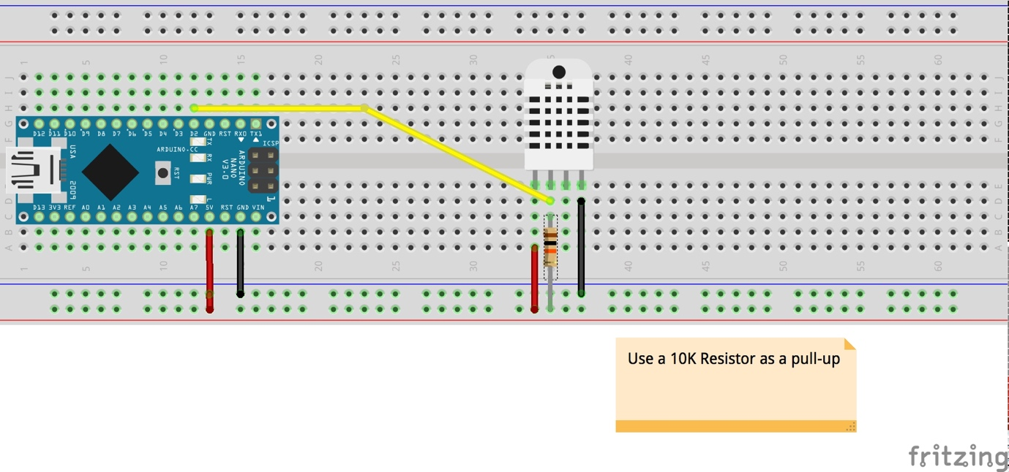

You will want to place a 10K resistor between VCC and the data pin, to act as a medium-strength pull up on the data line. A “pull up” ensures that the signal that is output from the Arduino is correctly recognized

4 Download a driver and example code from the following repository

<https://github.com/adafruit/DHT-sensor-library>

Copy the DHT folder into the Libraries folder of the Arduino IDE installation location to install the dht.cpp driver files.

4 Open the Arduino sketch – DHTTester.ino

#include <DHT.h>

// Example testing sketch for various DHT humidity/temperature sensors

// Written by ladyada, public domain

#include "DHT.h"

#define DHTPIN 2 // what digital pin we're connected to

// Uncomment whatever type you're using!

#define DHTTYPE DHT11 // DHT 11

//#define DHTTYPE DHT22 // DHT 22 (AM2302), AM2321

//#define DHTTYPE DHT21 // DHT 21 (AM2301)

// Connect pin 1 (on the left) of the sensor to +5V

// NOTE: If using a board with 3.3V logic like an Arduino Due connect pin 1

// to 3.3V instead of 5V!

// Connect pin 2 of the sensor to whatever your DHTPIN is

// Connect pin 4 (on the right) of the sensor to GROUND

// Connect a 10K resistor from pin 2 (data) to pin 1 (power) of the sensor

// Initialize DHT sensor.

// Note that older versions of this library took an optional third parameter to

// tweak the timings for faster processors. This parameter is no longer needed

// as the current DHT reading algorithm adjusts itself to work on faster procs.

DHT dht(DHTPIN, DHTTYPE);

void setup() {

Serial.begin(9600);

Serial.println("DHTxx test!");

dht.begin();

}

void loop() {

// Wait a few seconds between measurements.

delay(2000);

// Reading temperature or humidity takes about 250 milliseconds!

// Sensor readings may also be up to 2 seconds 'old' (its a very slow sensor)

float h = dht.readHumidity();

// Read temperature as Celsius (the default)

float t = dht.readTemperature();

// Read temperature as Fahrenheit (isFahrenheit = true)

float f = dht.readTemperature(true);

// Check if any reads failed and exit early (to try again).

if (isnan(h) || isnan(t) || isnan(f)) {

Serial.println("Failed to read from DHT sensor!");

return;

}

// Compute heat index in Fahrenheit (the default)

float hif = dht.computeHeatIndex(f, h);

// Compute heat index in Celsius (isFahreheit = false)

float hic = dht.computeHeatIndex(t, h, false);

Serial.print("Humidity: ");

Serial.print(h);

Serial.print(" %\t");

Serial.print("Temperature: ");

Serial.print(t);

Serial.print(" *C ");

Serial.print(f);

Serial.print(" *F\t");

Serial.print("Heat index: ");

Serial.print(hic);

Serial.print(" *C ");

Serial.print(hif);

Serial.println(" *F");

}

5 This example uses pin 2 of the Arduino as the input for the Pin 2 output of the DHT-11. You will have to ensure the correct Define function is uncommented for the model of sensor you are using.

The DHT library has functions to begin sensing, read the temperature (in Celsius or Fahrenheit ) and return a heat index (what a temperature feels like to the human body)

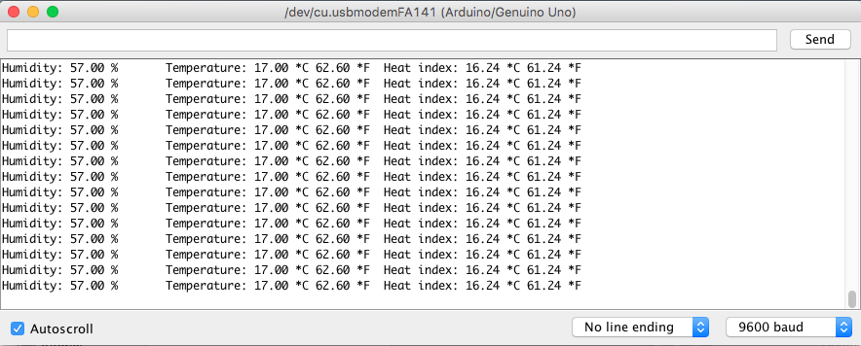

Give it a try!

6 What projects can you think that might make use of such a sensor?

Other useful sources of information:

<https://learn.adafruit.com/dht/using-a-dhtxx-sensor>